D424 – Software Engineering
Task 3
Capstone Proposal Project Name: |   Student Mobile App
Student Name: | Sean Theobald

Table of Contents

Table of Contents 2
Application Design and Testing 2
Class Design 2
UI Design 3
Unit Test Plan 9
Purpose 9
Overview 10
Test Plan 10
Features 10
Deliverables 11
Tasks 11
Needs 11
Pass/Fail Criteria 12
Specifications 13
Procedures 13
Results 14
Installation/Maintenance Guide……………………………………………………….…15
User Guide……………………………………………………………………………….18

Application Design and Testing

Class Design

The app follows a simple class structure optimized for readability and scalability. The core of the design is built around the AcademicItem base class. This defines shared attributes and establishes consistent behavior for all entities.

AcademicItem (Base Class)
-Contains core properties such as Id, Title, Start Date, and End Date.

Term Class
-Inherits from AcademicItem.
-Each Term contains multiple Course objects.

Course Class
-Inherits from AcademicItem.
-Represents a course within a specific term.

Assessment Class
-Inherits from AcademicItem.
-Represents an assessment belonging to a course.

The Database class handles all database operations within the Data folder. This service uses SQLite-net for persistence. This handles all CRUD operations.

Class Diagram
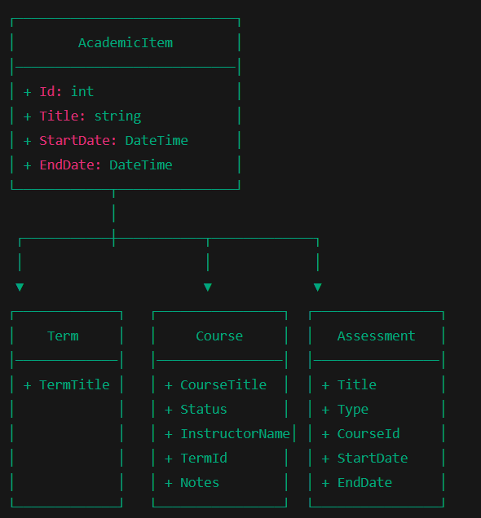

UI Design
When designing the app, usability and simplicity were the primary goals, with a focus on modern mobile UI conventions. Each page is optimized for readability and touch interaction. The UI consists of a main shell with flyout navigation and multiple functional pages. Each page uses consistent styling and spacing for inputs, buttons, and text. CRUD functionality, a search page, reporting, input validation/error handling, and user authentication are handled in the UI. Let me break down the key functionality of each page, accompanied by additional screenshots.

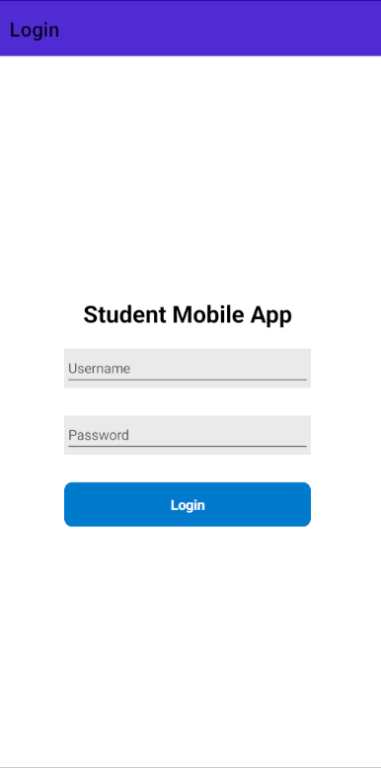
Login Page:
The login screen simulates user authentication and includes validation for required fields. It features a simple layout with:
- Username and password inputs
- A “Login” button
- Error messages for missing fields

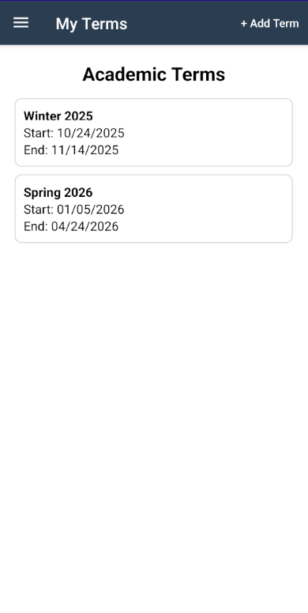
Terms List Page:
This is the landing page after login.
It displays all academic terms stored in the database in a CollectionView.
Each term shows:
- Title
- Start and end dates

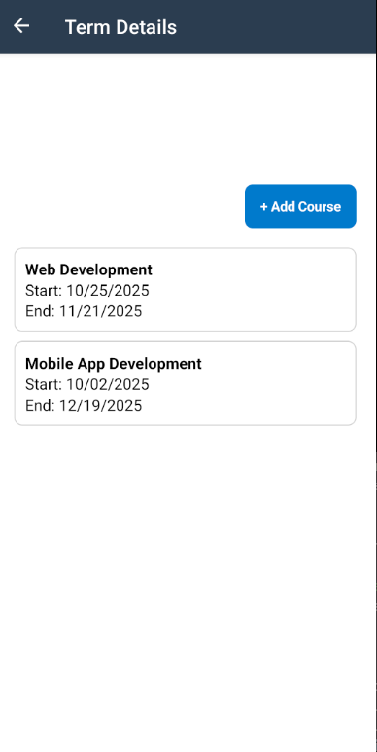
Term Detail Page:
Shows all courses associated with the selected term. Includes:
- A list of courses with their titles and statuses
- A button to add a new course
- Tap navigation to open a course detail page

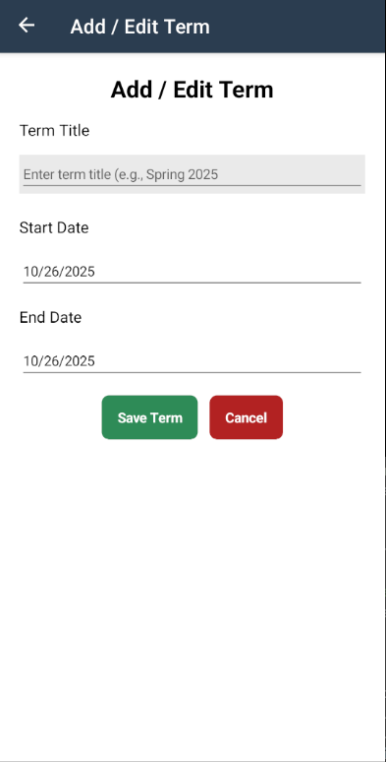
Add/Edit Term Page:
Shows all courses associated with the selected term.
Includes:
- A list of courses with their titles and statuses
- A button to add a new course
- Tap navigation to open a course detail page

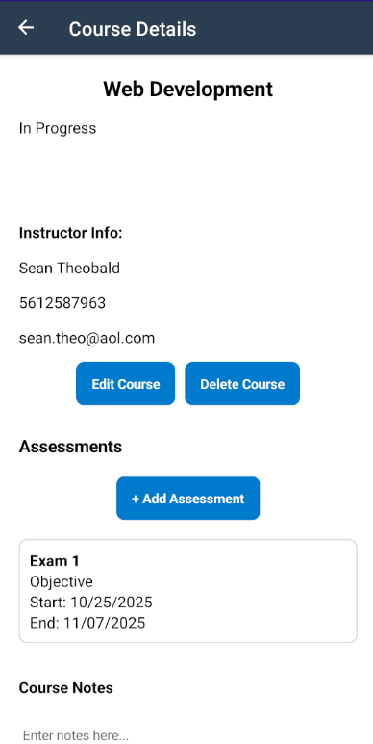
Course Detail Page:
Displays details for a specific course, including:
- Title, status, and instructor information
- Buttons to edit or delete the course
- Notes section with save/share functionality
- List of associated assessments with tap navigation

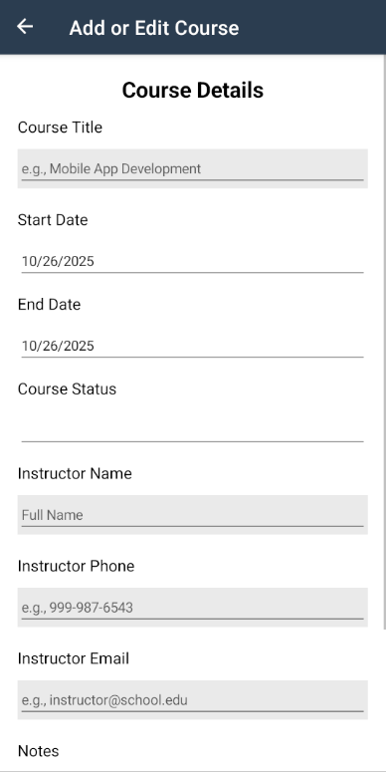
Add/Edit Course Page:
Form for creating or editing a course. Includes:
- Fields for course title, instructor info, and notes
- Status picker (e.g., In Progress, Completed)
- Date pickers for start/end dates
- Validation for email, phone, and required fields

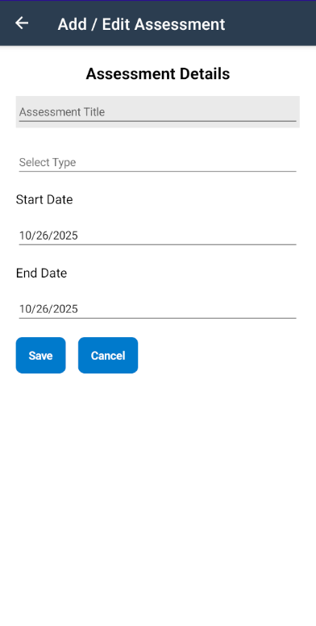
Add/Edit Assessment Page:
Form for creating or editing an assessment.
Includes:
- Title entry
- Type picker (e.g., Objective, Performance)
- Start and end date pickers
- Validation for title and date ranges

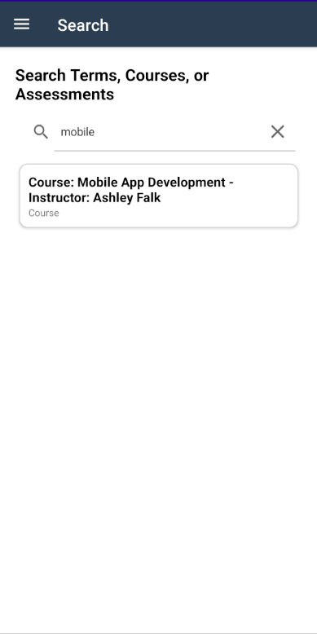
Search Page:
Search functionality allows users to find terms, courses, and assessments from a single interface.
Displays:
- A search bar
- A CollectionView listing matching results across multiple entities

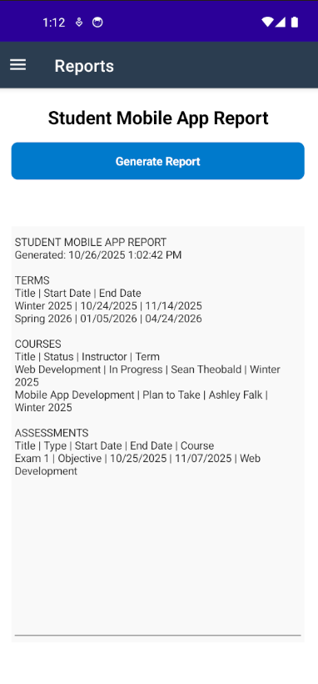
Reports Page:
Displays summarized information for all terms, courses, and assessments. Users can generate an in-app report with timestamps showing the full dataset. Data is displayed in read-only editors for review.

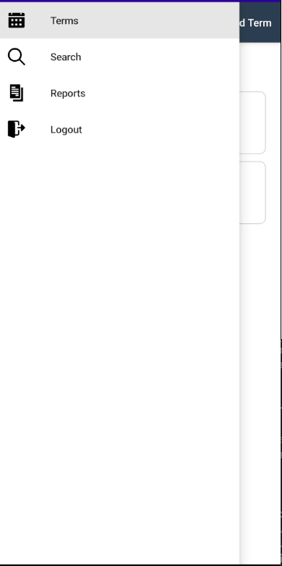
Flyout Navigation:
The flyout menu provides quick access to:
- Terms
- Search
- Reports
- Logout

Unit Test Plan

Introduction
The purpose of testing the Student Mobile App was to verify that all core functions—term, course, and assessment management—operate correctly and reliably on Android devices.
Testing was conducted manually through emulator sessions within Visual Studio 2022, combined with targeted logic validation using the ValidationHelper class and database CRUD operations. This process ensured that the application met all functional requirements for the capstone, including input validation, persistence, and notifications.

Purpose
The goal of the unit tests was to validate that:
- Each form (Term, Course, Assessment) correctly performs add, edit, and delete operations.
- Validation logic prevents incorrect or incomplete data entry.
- SQLite data persistence behaves correctly across sessions.
- Notifications trigger appropriately for assessment and course start/end dates.
Testing also aimed to verify that navigation between pages and data filtering (search and reports) were stable and intuitive.

Overview
Testing was conducted in three phases:
- Logic Verification – unit-style tests in C# for ValidationHelper and database methods.
- Functional Testing – running the app in the Android emulator and manually performing CRUD operations.
- Integration Testing – ensuring that database operations, page navigation, and notifications work cohesively.
All testing was iterative: each identified issue (e.g., incorrect validation or UI crashes) was fixed and then re-tested before moving to the next stage.

Test Plan
Category | Description
Items | ValidationHelper methods, Database CRUD functions, Add/Edit/Delete forms, Notification triggers.
Features | Data validation, term/course/assessment creation, editing, and deleting, notification scheduling
Deliverables | Verified working codebase, screenshots of validation and CRUD operations, no crash reports
Tasks | Run app in emulator → Perform CRUD on each entity → Trigger validation errors → Observe notifications.
Needs | Visual Studio 2022, Android SDK, .NET MAUI 8, SQLite-net-pcl, Plugin.LocalNotification
Pass/Fail Criteria | Operations complete without error; invalid input is blocked; correct alerts appear; data persists after app restart.
Specifications | Manual test scripts (described below) and ValidationHelper code samples

Deliverables
Tests should produce a screenshot to confirm test pass, unit test log, updated code with fixes (if needed), and a final report.

Tasks
Task | Description | Outcome
T1 | Execute Add/Edit/Delete for Term | Passed
T2 | Execute Add/Edit/Delete for Course | Passed
T3 | Validate empty fields & invalid input | Validation errors displayed
T4 | Verify report generation output | Text report generated successfully
T5 | Search multi-row data | Expected results returned

Pass/Fail Criteria
Pass: | The feature performs as intended with no exceptions or incorrect data output.
Fail: | The feature produces errors, incorrect data, or unresponsive UI behavior.

In the case of failure:

The bug is logged and reproduced.

The related logic is updated and retested.

The fix is committed to the working branch in GitLab.

Sample Unit Test Scripts

ValidationHelper Test
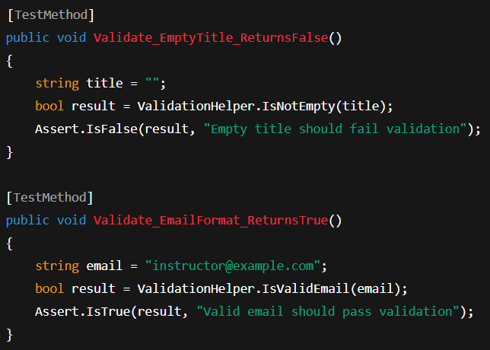
Database CRUD Test
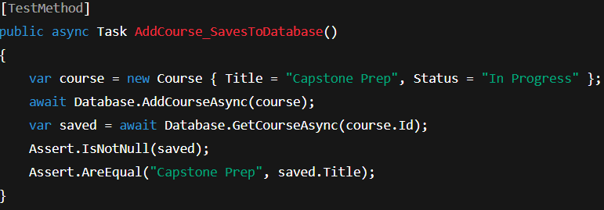

Procedures
- Launched the app in the Visual Studio Android emulator.
- Created new terms, courses, and assessments to verify the “Add” workflow.
- Attempted to save incomplete forms (blank title, invalid dates) to test validation handling.
- Edited and deleted existing entries to confirm CRUD reliability.
- Verified that local notifications appeared for assessments with matching start/end dates.
- Restarted the emulator and confirmed that database records persisted.
- Documented outcomes and re-tested any corrected issues.

Results
A few issues were identified early on :
- Issue: An Orphaned assessment remained after deleting a course.
Fix: Added cascade delete to DeleteCourseAsync().
- Issue: Form validation didn’t prevent an empty “Course Title.”
Fix: Integrated ValidationHelper.IsNotEmpty() across all forms.
- Issue: Initial report layout was too complex for mobile display.
Fix: Simplified to an in-app text viewer for better usability.

All CRUD and validation tests passed successfully.
Test ID | Feature Tested | Expected Result | Actual Result | Status
T1 | Add Term | Term saved and displayed | Success | Pass
T2 | Edit Term | Updated details visible | Success | Pass
T3 | Delete Term | Term and linked courses removed | Success | Pass
T4 | Add Course | Course saved under the correct term | Success | Pass
T5 | Edit Course | Updated fields reflected | Success | Pass
T6 | Delete Course | Removed and assessments deleted | Success | Pass
T7 | Add Assessment | Appears in course details | Success | Pass
T8 | Search | Correct results for the query | Success | Pass
T9 | Report Generation | All data is shown with a timestamp | Success | Pass
T10 | Validation | Invalid entries trigger a warning | Success | Pass
T11 | Notifications | Triggers for start/end dates | Success | Pass
Result Summary:
All test cases passed after remediation.
No critical bugs remain.
Application functions meet WGU’s rubric requirements.
C2. Provide a link to where the web app is hosted, along with the HTML code (if applicable).
https://d424-software-engineering-capstone-962b8c.gitlab.io
C3. Provide a link to the GitLab repository of the code, indicating the version included in this submission.

https://gitlab.com/wgu-gitlab-environment/student-repos/stheob9/d424-software-engineering-capstone/-/tree/working

Version 1.0
C4. User Guide for Setting Up and Running the Application for Maintenance Purposes.

Introduction
This section provides detailed instructions for technical staff or developers. It explains how to configure the development environment, restore dependencies, perform database maintenance, and deploy new versions to GitLab Pages.

1. System Requirements
Hardware:
- Windows 10 or 11 (x64)
- Minimum 8 GB RAM (16 GB recommended)
- At least 15 GB free disk space
Software:
- Visual Studio 2022 (Community, Professional, or Enterprise)
- .NET 8 SDK
- Android SDK Tools
- .NET MAUI workload
- Git for version control
- SQLite Browser (optional, for local data inspection)

2. Project Setup Instructions
- Clone the Repository
- git clone https://gitlab.com/wgu-gitlab-environment/student-repos/stheob9/d424-software-engineering-capstone.git
- cd d424-software-engineering-capstone/StudentMobileApp
Ensure you are working on the correct branch:
git checkout working
- Open the Solution in Visual Studio
  - Double-click StudentMobileApp.sln.
  - Allow Visual Studio to load all dependencies automatically.
- Restore Dependencies
  - From the Solution Explorer, right-click the project and select “Restore NuGet Packages.”
  - Confirm that the file project.assets.json is generated in /obj/.
- Select Build Configuration
  - Set Configuration: Debug or Release
  - Set Platform: Android
- Run or Deploy the App
  - To test locally: connect an Android device (with USB debugging enabled) or use the Android Emulator.
  - Select Run → Debug > Android Emulator or Device.
  - Visual Studio will build and deploy the .apk automatically.

3. SQLite Database Maintenance
- The application stores all data locally using SQLite-net ORM.
- The database file is created on the first run in the local app directory:
- /data/data/com.companyname.studentmobileapp/databases/StudentApp.db3
To reset the database:
- Delete the existing StudentApp.db3 file from the emulator/device.
- Relaunch the app — a fresh schema will be auto-generated.
To inspect data manually (optional):
- Use “DB Browser for SQLite.”
- Copy the .db3 file to your PC via Android Device Explorer in Visual Studio.

4. Updating Dependencies and MAUI Version
When new .NET MAUI or NuGet package versions are released:
- In Visual Studio → Tools > NuGet Package Manager > Manage NuGet Packages for Solution.
- Select the Updates tab.
- Update all packages (especially Microsoft.Maui.* and CommunityToolkit.Mvvm).
- Rebuild and test the app.
- Commit the updates with a message such as:
- git commit -m "Updated MAUI and NuGet dependencies to latest stable versions"

5. Rebuilding the Signed APK
To prepare a new release version of the app:
- Switch configuration to Release in the toolbar.
- In Visual Studio, click Build → Publish → Android → APK (Signed).
- Save the generated .apk file to /StudentMobileApp/bin/Release/net8.0-android/.
- Rename it to StudentMobileApp.apk.
- Copy it into the public/ folder of the repository.
- Push the changes to GitLab:
- git add public/StudentMobileApp.apk
- git commit -m "Updated release APK for version 1.1"
- git push origin working
- GitLab CI/CD will automatically redeploy the updated file to GitLab Pages.

6. Version Control and Branching
- The primary branch for this project is working.
- Use descriptive branch names for future updates (e.g., feature/notifications or fix/ui).
- Always merge changes into working and tag versions accordingly:
- git tag -a v1.1 -m "Bug fixes and updated reports page"
- git push origin v1.1

- Common Maintenance Tasks

Task | Description | Tool / Command
Update splash/logo assets | Replace files in Resources/Splash or Resources/AppIcon | Rebuild project
Reset database | Deletes and regenerates StudentApp.db3 | Via emulator or app settings
Test notifications | Simulate course or assessment reminders | Device/Emulator
Change app colors or styles. | Edit Resources/Styles/Colors.xaml and Styles. xaml | Save & rebuild
Modify validation rules | Adjust logic in ValidationHelper.cs | Save & rebuild

8. Contact and Ownership
Maintainer: Sean Theobald
Institution: Western Governors University
Program: Software Engineering – Capstone (D424)
Repository: GitLab – D424 Capstone Project
Version: v1.0-final

C5. User guide for running the application from a user perspective

1. Installation

1.1 Download the Application
- Open your device’s web browser and go to:
https://d424-software-engineering-capstone-962b8c.gitlab.io/StudentMobileApp.apk
- Tap Download when prompted.

1.2 Enable App Installation
If your phone blocks installation from unknown sources:
- Go to Settings → Apps → Special Access → Install unknown apps.
- Choose your browser and toggle Allow from this source.

1.3 Install the App
- Locate the downloaded StudentMobileApp.apk in your Downloads folder.
- Tap the file to begin installation.
- Once complete, tap Open to launch the app.

2. Logging In
- When the app launches, you’ll see a login screen.
- Enter your username and password, then tap Login.
(Default test account: username “test”, password “password” if no user database is configured.)
- If credentials are valid, you’ll be taken to the Terms dashboard — your main navigation.

3. Navigation Overview
The app uses a fly-out menu for easy navigation between major sections:
- Terms – view and manage all academic terms
- Search – search for courses or assessments
- Reports – generate simple summaries of progress
- Logout – sign out of the application
Each section features consistent layouts, clear buttons, and simple, color-coded forms for enhanced clarity and readability.

4. Managing Academic Terms

4.1 Add a New Term
- From the Terms page, tap the ➕ Add Term button.
- Enter the term title, start date, and end date using the provided date pickers.
- Tap Save. The new term appears immediately in the list.

4.2 Edit or Delete a Term
- Tap a term name to view its details.
- Use the Edit button to change details or Delete to remove it permanently.
- Confirm when prompted to prevent accidental deletions.

5. Managing Courses

5.1 Add a Course
- Open a term, then tap Add Course.
- Fill in:
  - Course title
  - Start and end dates
  - Status (In Progress, Completed, Dropped, etc.)
  - Instructor’s name, phone, and email
- Optionally, add notes and enable notifications for start/end dates.
- Tap Save to store the course locally in the app’s SQLite database.

5.2 Edit or Delete a Course
- Open a course → tap Edit to update details or Delete to remove it.
- Any changes are automatically saved locally.

6. Managing Assessments
- Open a course and tap Add Assessment.
- Choose Performance or Objective assessment type.
- Provide the title, start date, and due date.
- Enable optional notifications for reminders.
- Tap Save. The assessment appears in the course view.

7. Notifications
- Notifications appear automatically when a term, course, or assessment date is near.
- They display the item’s name and date, ensuring students stay on schedule.
- Notifications can be toggled per course or assessment via the switch control on their edit pages.

8. Search and Reports

8.1 Using Search
- Access Search from the fly-out menu.
- Enter any keyword (e.g., course name, instructor, or assessment).
- Results will show all matching records, grouped by type.

8.2 Viewing Reports
- Open Reports from the menu.
- Reports summarize courses and assessments by term, showing counts and completion status.
- You can capture screenshots or export text summaries for record-keeping.

9. Logging Out
- From the menu, tap the Logout 🚪 option.
- You’ll be returned to the login page, and your session will end.

10. Troubleshooting
Issue | Possible Cause | Solution
App won’t install | Unknown-sources disabled | Enable “Install unknown apps” for your browser
Blank screen after login | No terms exist | Add a new term using “+ Add Term”
Notifications not appearing | Permissions not granted | Check Android settings → Notifications → enable for this app
Data not saving | SQLite file corrupted | Precise app data or reinstall the app

11. Uninstallation
To remove the app:
- Go to Settings → Apps → Student Mobile App
- Tap Uninstall and confirm.

12. Support
For issues or maintenance requests, contact:
Developer: Sean Theobald
Institution: Western Governors University
Course: D424 – Software Engineering Capstone
Repository: GitLab – StudentMobileApp Project
F. Acknowledge sources, using in-text citations and references, for content that is quoted, paraphrased, or summarized.
No outside sources used

